Install Docker
Tasks
1.
Install Docker Desktop or Docker Engine on your local machine and verify the installation by running the command docker --version in your terminal.
2.
Pull the official Nginx Docker image from Docker Hub using the command docker pull nginx and list all downloaded images with docker images.
3.
Start a new Nginx container using the command docker run -d -p 8080:80 --name mynginx nginx, then open your browser and check if you can access the default Nginx welcome page at http://localhost:8080.
4.
Create a Docker volume named zomato_data using docker volume create and attach it to a new container running the httpd (Apache) image so that any data written to /usr/local/apache2/htdocs inside the container is stored persistently.<br><br><em><strong>Hint:</strong> Use the -v flag with docker run to mount the volume.</em>
5.
Compare containers and virtual machines by listing 3 benefits of Docker containers over traditional VMs, using examples from apps like Zomato, Instagram, or Flipkart.

Answer : 1. Install Docker and verify it
If you are using Windows or macOS
Install Docker Desktop from the official Docker website:
Docker Desktop
After installation, open Docker Desktop and wait until Docker is running.
Then open:
- Windows → PowerShell or Command Prompt
- macOS → Terminal
- Linux → Terminal
Run:
docker --version
You should see something similar to:
Docker version 28.x.x, build xxxxx
What does this mean?
docker --version checks whether Docker is installed and available from your terminal.
✅ Task 1 complete when you get a Docker version.

2. Download the Nginx image
Now run:
docker pull nginx
What is happening?
Docker downloads the official Nginx image from Docker Hub.
Think of an image as a ready-made template containing everything needed to create a container.
You should see output similar to:
Using default tag: latest
latest: Pulling from library/nginx
...
Status: Downloaded newer image for nginx:latest
Now list your downloaded images:
docker images
You should see something like:
REPOSITORY TAG IMAGE ID CREATED SIZE
nginx latest xxxxxxxxxxxx ... ...
Important terms
- Image → Template/package used to create containers.
- Container → A running instance created from an image.
- nginx → A popular web server.
✅ Task 2 complete.

3. Run an Nginx container
Now create and start your Nginx container:
docker run -d -p 8080:80 --name mynginx nginx
Let's understand each part:
docker run
Creates and starts a container.
-d
Runs it in the background (detached mode).
-p 8080:80
Connects:
Your computer's port 8080 → Container's port 80
--name mynginx
Gives the container the name mynginx.
nginx
Tells Docker to use the Nginx image.
Check that it is running
Run:
docker ps
You should see something similar to:
CONTAINER ID IMAGE COMMAND ... PORTS
xxxxxxxx nginx ... 0.0.0.0:8080->80/tcp

Open Nginx in your browser
Go to:
http://localhost:8080
You should see the Welcome to nginx! page.
🎉 If you see that page, your Docker Nginx container is working.

A useful command
To stop the container:
docker stop mynginx
To start it again:
docker start mynginx
To remove it:
docker rm mynginx
If you remove it, you'll need to run the docker run command again to recreate it.
✅ Task 3 complete.

4. Create and use a Docker volume
Now we're going to learn about persistent storage.
First create a volume:
docker volume create zomato_data
You should get:
zomato_data
You can check your volumes with:
docker volume ls
You should see:
DRIVER VOLUME NAME
local zomato_data

What is a Docker volume?
Normally, data inside a container is tied to that container's writable layer. If you remove the container, that data can disappear.
A volume stores data outside the container's writable layer, so the data can survive container replacement/removal.
For example, imagine Zomato has a container storing application data. You wouldn't want important persistent data to disappear just because an application container was recreated.

Create an Apache container using the volume
Run:
docker run -d \
--name myapache \
-p 8081:80 \
-v zomato_data:/usr/local/apache2/htdocs \
httpd

If you're using Windows PowerShell
The multiline version may be easier as one line:
docker run -d --name myapache -p 8081:80 -v zomato_data:/usr/local/apache2/htdocs httpd

Understanding the important part
-v zomato_data:/usr/local/apache2/htdocs
means:
Docker volume Container directory
↓ ↓
zomato_data ───────────────> /usr/local/apache2/htdocs
Anything Apache writes to:
/usr/local/apache2/htdocs
is stored in the zomato_data volume.

Check the container
docker ps
You should see both containers if your Nginx container is still running:
mynginx
myapache
Open Apache in your browser:
http://localhost:8081
You should see the Apache default page (depending on the image/version).

Test that the volume works
You can create a small HTML file inside the Apache container.
Run:
docker exec myapache sh -c 'echo "<h1>Hello from Docker Volume</h1>" > /usr/local/apache2/htdocs/index.html'
Then open:
http://localhost:8081
You should see:
Hello from Docker Volume
Now remove the Apache container:
docker rm -f myapache
Notice: We did NOT remove the volume.
Check:
docker volume ls
You should still see:
zomato_data
Create another Apache container using the same volume:
docker run -d --name myapache2 -p 8081:80 -v zomato_data:/usr/local/apache2/htdocs httpd
Now visit:
http://localhost:8081
Your Hello from Docker Volume page should still be there.
🎉 That's persistence.

5. Docker containers vs Virtual Machines
Here are 3 important benefits of Docker containers over traditional VMs, with examples related to apps such as Zomato, Instagram and Flipkart.

1. Containers are lightweight
A virtual machine usually includes a complete guest operating system.
A Docker container shares the host machine's operating-system kernel, so it generally requires fewer resources.
For example, imagine an application like Zomato has separate services for:
- Restaurant search
- User accounts
- Payments
- Food delivery tracking
These services can be packaged into separate containers without requiring a complete VM for every service.
Benefit: Less overhead and more efficient resource usage.

2. Containers start very quickly
VMs generally need to boot an entire operating system.
Containers can usually start much faster because they don't need to boot a separate full OS.
For example, if Instagram needs to deploy a new version of an image-processing service, a container can be started quickly from its image.
Benefit: Faster deployment and scaling.

3. Containers make applications easier to move
A Docker image packages an application's environment and dependencies.
For example, suppose developers build a Flipkart service on their laptops.
Without containers, they might encounter:
"It works on my computer, but not on the server."
With Docker, they can package the application into an image and run that image in different environments.
Developer laptop
↓
Docker Image
↓
Testing server
↓
Production server
Benefit: More consistent environments between development, testing and production.

Quick summary
Task | Command
Check Docker | docker --version
Download Nginx | docker pull nginx
List images | docker images
Run Nginx | docker run -d -p 8080:80 --name mynginx nginx
Check containers | docker ps
Create volume | docker volume create zomato_data
List volumes | docker volume ls
Run Apache with volume | docker run -d --name myapache -p 8081:80 -v zomato_data:/usr/local/apache2/htdocs httpd
Stop container | docker stop mynginx
Remove container | docker rm mynginx
The main idea to remember
Docker Image
↓
docker run
↓
Docker Container
↓
Application runs
And for persistent data:
Docker Container
↕
Docker Volume
↓
Persistent data
If you're doing this as a college practical/lab, you can copy the commands above one at a time and verify each output before moving to the next task.

🐳 First: Understand the basic Docker picture
Think of Docker like this:
DOCKER
│
┌────────┴────────┐
│ │
Nginx Image Apache Image
│ │
↓ ↓
Nginx Container Apache Container
│ │
↓ ↓
localhost:8080 localhost:8081
An image is the template. A container is the running application created from that template.

🟢 TASK 1 — Install Docker
After installing Docker Desktop, open it.
You should see a Docker Desktop dashboard similar to this:
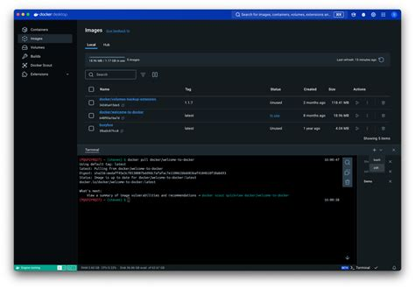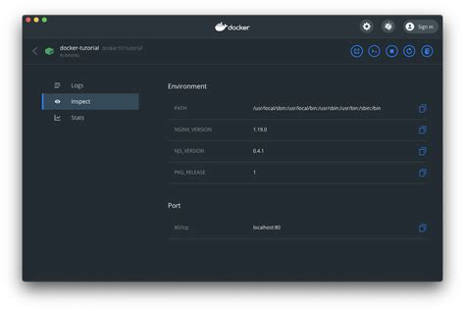
Then open your terminal and type:
docker --version

Example output
Docker version 28.x.x, build xxxxx

What you are checking
Your computer
↓
Docker installed?
↓
docker --version
↓
Docker version appears ✅
Small info: Docker Desktop provides Docker Engine plus a graphical interface for managing containers, images, volumes, etc.

🟢 TASK 2 — Download Nginx
Now type:
docker pull nginx
You will see Docker downloading several layers.
For example:
Using default tag: latest
latest: Pulling from library/nginx

Pull complete
Pull complete
Pull complete

Status: Downloaded newer image for nginx:latest
Docker's documentation confirms that nginx is available as a Docker Official Image and can be pulled from Docker Hub.
Now type:
docker images
You should see something similar to:
REPOSITORY TAG IMAGE ID CREATED SIZE
nginx latest abc123456789 ... ...

Visual idea
Docker Hub
│
│ docker pull nginx
↓
┌─────────────────┐
│ NGINX IMAGE │
│ │
│ nginx:latest │
└─────────────────┘
Here's an example of a Docker terminal showing an Nginx image being pulled and a container being started:

🟢 TASK 3 — Start Nginx
Now run:
docker run -d -p 8080:80 --name mynginx nginx

Understand this command
docker run
↓
Create container

-d
↓
Run in background

-p 8080:80
↓
Computer port 8080
↓
Container port 80

--name mynginx
↓
Container name

nginx
↓
Use nginx image
The important part is:
8080:80
It means:
YOUR COMPUTER CONTAINER

localhost:8080 ───────────→ port 80
Nginx
Docker documents -p HOST_PORT:CONTAINER_PORT as the port-publishing format.

Check it
docker ps
Example:
CONTAINER ID IMAGE STATUS PORTS
abc123 nginx Up 1 minute 0.0.0.0:8080->80/tcp
You can also visualize port mapping like this:

🌐 Now open your browser
Type:
http://localhost:8080
You should see:
Welcome to nginx!

If you see this page, the nginx web server
is successfully installed and working.

🎉 This is the most important screenshot for Task 3.
Docker's own documentation specifically describes running Nginx with port 8080:80 and opening http://localhost:8080 to see the Nginx page.
Your complete flow
NGINX IMAGE
│
│ docker run
↓
┌───────────────┐
│ mynginx │
│ │
│ Nginx :80 │
└───────┬───────┘
│
port mapping
│
↓
http://localhost:8080
│
↓
🌐 Web Browser
│
↓
"Welcome to nginx!"

🟢 TASK 4 — Docker Volume
Now let's make the Apache example easier to understand.
First create the volume:
docker volume create zomato_data
Then:
docker volume ls
You should see:
DRIVER VOLUME NAME

local zomato_data

📦 What is the volume?
Imagine Zomato has an application container:
┌───────────────────────────┐
│ Zomato Container │
│ │
│ Website / Application │
│ │
│ /usr/local/... │
└─────────────┬─────────────┘
│
↓
zomato_data
Docker Volume
│
↓
💾 Persistent data
The important idea is:
Container can be deleted → Volume can remain.
This is why volumes are useful for persistent data. A Docker volume is managed separately from a container.

Start Apache with the volume
Run:
docker run -d --name myapache -p 8081:80 -v zomato_data:/usr/local/apache2/htdocs httpd
The important section is:
-v zomato_data:/usr/local/apache2/htdocs
Meaning:
Docker Volume Apache Container

zomato_data ───────────────────→ /usr/local/apache2/htdocs
💾 📁
Here's a visual example of Apache running inside a Docker container with its web directory connected to storage:
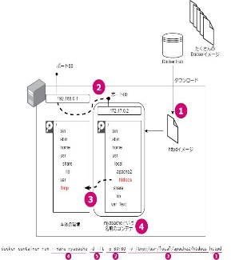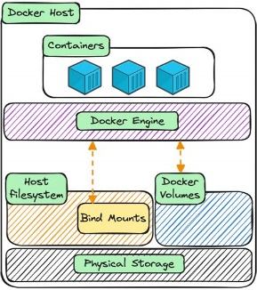

Test the Apache container
Run:
docker ps
You might now see:
CONTAINER ID IMAGE PORTS
abc123 nginx 0.0.0.0:8080->80/tcp
def456 httpd 0.0.0.0:8081->80/tcp
So you have:
http://localhost:8080
↓
NGINX
│
│
http://localhost:8081
↓
APACHE
Open:
http://localhost:8081
You should get the Apache web page.

🟢 TASK 5 — Real-world examples
Now imagine a large application such as Zomato.
Instead of putting everything into one huge application, you could have different services:
ZOMATO
│
┌───────────┼───────────┐
↓ ↓ ↓
User Service Food Service Payment
│ │ │
Container Container Container
Similarly, an Instagram-like application could have:
INSTAGRAM
│
┌─────────┼─────────┐
↓ ↓ ↓
Login Photos Messaging
│ │ │
Container Container Container
And an e-commerce application like Flipkart could have:
FLIPKART
│
┌──────────┼──────────┐
↓ ↓ ↓
Products Orders Payments
│ │ │
Container Container Container

Why containers are useful here?
1. Lightweight
Instead of running a complete operating system for every service, containers share the host's OS kernel.
2. Fast startup
A container can generally start much faster than a VM that has to boot a complete guest OS.
3. Easy deployment
You can package a service as an image:
Developer
↓
Docker Image
↓
Testing
↓
Production
This helps reduce the classic:
"It works on my computer!" 😄
problem.

📸 Screenshots you should collect for your practical
If this is for a college assignment, I recommend taking these screenshots:

Screenshot 1
After:
docker --version
Show the Docker version.

Screenshot 2
After:
docker images
Show the nginx image.

Screenshot 3
After:
docker ps
Show mynginx running.

Screenshot 4 ⭐
Browser:
http://localhost:8080
Show Welcome to nginx!

Screenshot 5
After:
docker volume ls
Show:
zomato_data

Screenshot 6
After:
docker ps
Show both:
mynginx
myapache

Screenshot 7
Browser:
http://localhost:8081
Show the Apache page.

🧠 One picture to remember everything
DOCKER HUB
│
docker pull nginx
│
↓
┌─────────────┐
│ NGINX IMAGE │
└──────┬──────┘
│
docker run
↓
┌─────────────┐
│ mynginx │
│ Nginx │
│ :80 │
└──────┬──────┘
│
8080:80
│
↓
🌐 localhost:8080
│
↓
Welcome to nginx!

APACHE EXAMPLE
│
┌──────▼──────┐
│ myapache │
│ httpd │
└──────┬──────┘
│
↕
┌─────────────┐
│ zomato_data │
│ VOLUME │
└─────────────┘
Docker's documentation also provides screenshots/examples of the Docker Desktop container view and accessing a container through localhost:8080.

